Install Debian 11 on the Rock Pi 4
Project: Debian 11 on the Rock Pi 4
Author: Staffan Melin, staffan.melin@oscillator.se
License: GNU General Public License v3.0.
Version: 1.0.0 (20220622)
Project site: http://oscillator.se/opensource

Introduction
Instructions on how to install Debian 11 on the Rock Pi 4.
I used a Rock Pi 4 A with an USB dongle, working on a Debian 11 laptop.

Instructions

Info from the manufacturer
https://wiki.radxa.com/Rockpi4/Debian

Burn the SD card
Download and burn the Debian image to a microSD card.
https://wiki.radxa.com/Rockpi4/downloads
I used the Balena Etcher, available on the same page, for burning.

Boot
Insert the card into the Rock Pi 4.
Attach a screen, keyboard and mouse and a power adapter.
The Rock Pi 4 boots directly to the login page.
User password is rock/rock.
Login and set the root password.

Fix usb dongle (optional)
I had the Rock Pi 4 A without WIFI, so I used a dongle with an Ralink chipset.
Check out dongle version by inserting the dongle and check the vendor info in dmesg.txt.
Look it up on this page: https://devicehunt.com/view/type/usb/vendor/148F/device/7601
apt install firmware-ralink
If you experience WIFI droputs check out this link: https://raspberrypi.stackexchange.com/questions/15142/wifi-drops-on-raspberry-pi

Setup your network
nano /etc/wpa_supplicant/wpa_supplicant.conf
and enter
country=us
update_config=1
ctrl_interface=/var/run/wpa_supplicant
network={
scan_ssid=1
ssid="MyNetworkSSID"
psk="Pa55w0rd1234"
}
Make SSH pemit root login:
sudo nano /etc/ssh/sshd_config
and change this line
PermitRootLogin yes
From: https://www.addictivetips.com/ubuntu-linux-tips/enable-root-ssh-login-linux/
Set WIFI to auto login:
nmcli dev wifi connect "wifi_name" password "wifi_password"
(I am unsure if this last step really is necessary.)
Clean up and remove
- xfce4
- x11
- lightdm
- cups
to make the installation headless.
Reboot:
sudo reboot
Now you can login using SSH from another computer in your network.
Scan the network
sudo nmap -sn 192.168.1.0/24
and login using
ssh rock@<ip>

Update to Debian 11
Update Debian to version 11 using any good guide on the web.

Fix the sound
I had no working sound on the Rock Pi 4.
Install some useful tools:
apt install alsa-utils
To see all audio devices
aplay -l
You can now test ALSA using
aplay /usr/share/sounds/alsa/*
or
speaker-test -t wav -c 2
I could fix this using
alsamixer
So the two settings to the left are obvious:
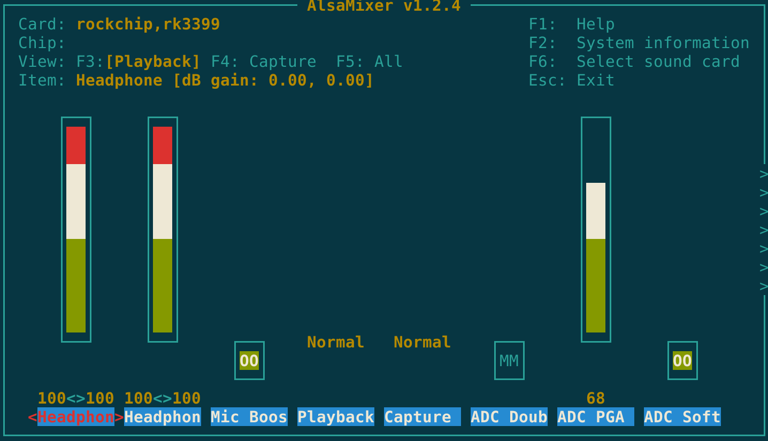
But there are a bunch of settings to the right that you have to change. Press . to get a "00".
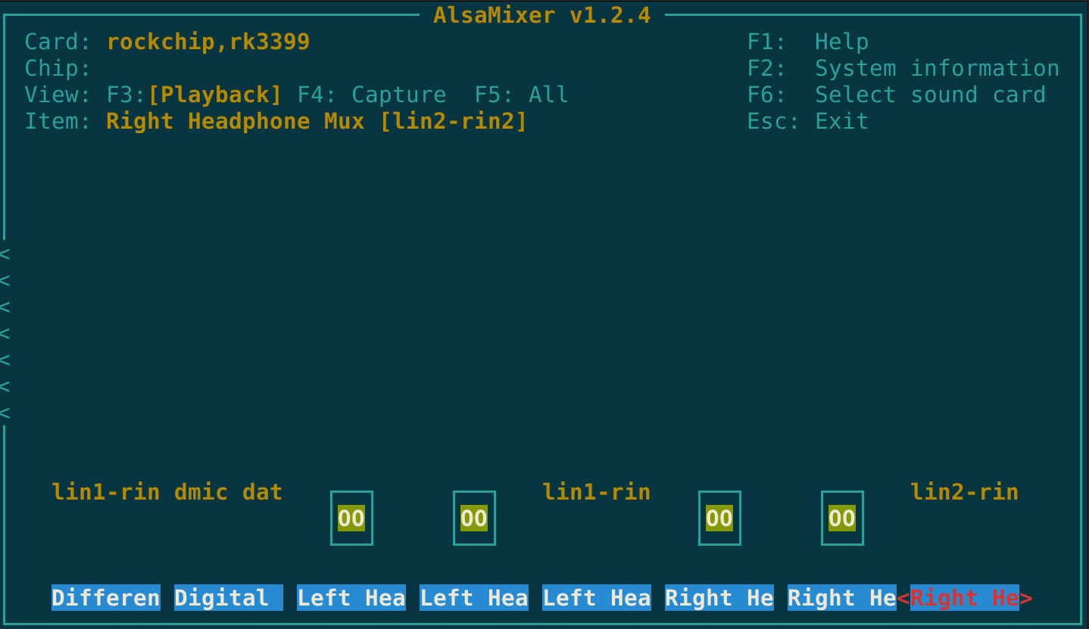

Pulseaudio
If you want Pulseaudio
apt install pulseaudio pulseaudio-utils
You can test pulseaudio using
paplay
If you want Pulseaudio to work in realtime you have to
sudo nano /etc/security/limits.conf
and change
rock soft rtprio unlimited
rock hard rtprio unlimited
Then (maybe)
cp /etc/pulse/daemon.conf ~/.config/pulse/
and uncomment realtime in ~/.config/pulse/.
References:
- https://linuxrelatedstuff.blogspot.com/2014/05/tutorial-for-linux-thread-scheduling.html
- https://wiki.archlinux.org/title/PulseAudio/Examples
- https://shallowsky.com/linux/pulseaudio-command-line.html

Additional info

Architecture
The processor ARM Cortex A72 has the ARM8 architecture.

Reboot and poweroff
Reboot:
sudo reboot
Poweroff:
sudo poweroff
The red heartbeat LED stops.

